

Hybrid Conference on Catalysing African Science through scientific partnership

Concept Note & Programme of Work (Agenda)
Dates: 24⁻25 July 2025 | Time: 09h00 – 16h00 (Kinshasa time, GMT+2)

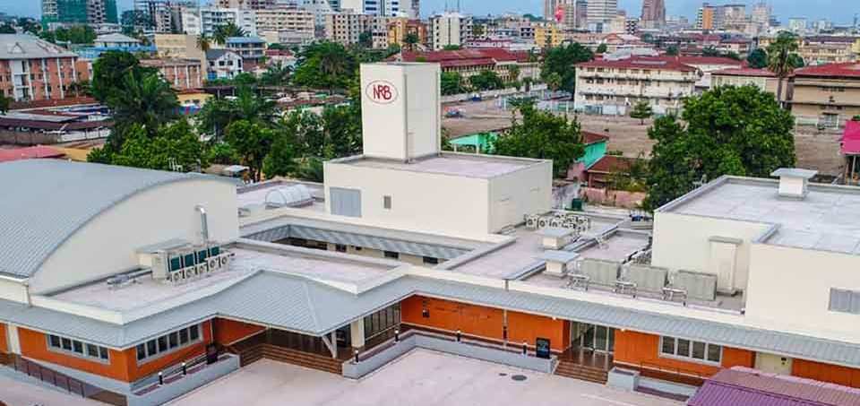
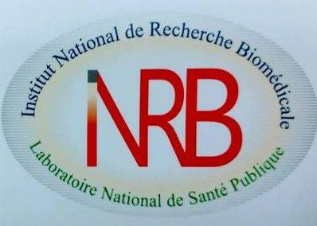 | Venue:  Institut National de Recherche Biomédicale (INRB)  Avenue de la Démocratie (formerly Avenue des Huileries)  Gombe Suburb, Capital City of Kinshasa
Juillet 2025
Conference on “Catalysing African Science through Scientific Partnership”

- CONCEPT NOTE (TERMES DE REFERENCE)

- Background
The DRC Ministry of Scientific Research and Technological Innovation and the Ministry of Public Health, Hygiene and Social Prevention, through the National Institute for Biomedical Research (Institut National de Recherche Biomédicale, INRB), in collaboration with the African Academy of Sciences (AAS), the European Union Delegation to the African Union, and the French National Centre for Scientific Research (CNRS), have engaged the African Union Development Agency-New Partnership for Africa’s Development (AUDA-NEPAD), the French Institute of Research for Development (IRD), the Spanish National Research Council (CSIC), and CNRS to co-organize a hybrid scientific conference aimed at showcasing ongoing research and exploring new avenues for collaboration with African researchers.

The two-day conference aims to foster scientific collaboration between researchers funded by the AAS (specifically through the African Research Initiative for Scientific Excellence (ARISE), the European Research Council (ERC), and the CNRS's multi-year cooperation roadmap.

- Objective
To highlight the launch of the second phase of the ARISE programme for Sustainable Development (ARISE SD) (2025-2030), in alignment with the AU-EU Innovation Agenda (2023-2032).

- Sub-objectives
- To initiate a dialogue on strengthening collaboration between European and African partners in Science, Technology, and Innovation (STI).
- To update participants on the implementation and progress of the ongoing AU-EU Innovation Agenda (2023-2032).
- To explore opportunities for collaboration between DRC and EU research stakeholders within the AU-EU framework.

- Key Activities
- Presentation of ARISE SD (2025-2030) and upcoming funding calls by the AAS for early-career, mid-career and senior researchers by Dr. Boniface USHIE.
- Overview of the AU-EU Innovation Agenda by the Co-Chairs of the Working Groups: Mr. Lukovi Seke (AUDA-NEPAD) and Dr. Vincenzo Lorusso (European Commission).
- Sharing of ARISE-funded research results. Case study from lead immunologist Prof. Dr. Dacquin Kasumba, in collaboration with CNRS researchers, focusing on zoonotic viral diseases, opportunities for scientific advancement, and associated challenges.
- Virtual presentations and discussions with ARISE grantees Dr. Christian Nkanga (DRC) and Dr. Grace Loubota Panzou (Republic of Congo). These sessions will be complemented by broader discussions on promoting Horizon Europe and the EU-Africa Initiative III calls to enhance DRC participation of the research and innovation community. The conference will follow a hybrid format.
- Presentation on the Congolese national research council, Congolese research institutes (CREN-K, CoE-CRBN, NCPIR, INRB, etc.), the incubator of Congolese genius, and ongoing discoveries (inventions) at the University of Kinshasa to be taken to the stage of innovation.
- An overview by the Ministry of Industry on the financial instruments supporting discoveries and innovation (market)

- Expected Outcomes
- Increased readiness in DRC for participation in the next cohort of funded early, middle career and established researchers under the AU-EU Innovation Agenda priorities (Public health, Green transition, Innovation and Technology, Capacities for Science, and Cross-cutting issues.
- Strengthened DRC and both AU and EU collaboration through current frameworks (Agenda 2063, STISA-2034, 2030 Agenda of SDGs, AU-EU Innovation Agenda, etc.).
- Enhanced visibility of DRC researchers and institutions for join projects with AU and EU stakeholders under ARISE-SD, Horizon Europe African Initiative III.
- Create collaborative opportunities between the ARISE-SD-funded grantees and other EU-based researchers.

Expected Participants and Speakers
Participants will include representatives from public research institutes, universities, tertiary institutions, some firms, various ministries (the Ministry of Scientific Research and Technological innovation, the Ministry of Industry, the Ministry of Economy, and the Ministry of Higher Education), AU and EU organs, French and Spanish research institutions, the EU representation in the Democratic Republic of Congo (DRC), and other research fellows from the Congolese scientific community.
The following speakers and moderators/facilitators are expected from 24 to 25 July 2025:
- His Excellency Prof. Dr. Gilbert KABANDA, Minister of Scientific Research and Technological Innovation of the DRC or his representative
- His Excellency Dr. Samuel Roger KAMBA, Minister of Public Health, Hygiene and Social Prevention
- Mr. Nicolas Berlanga MARTINEZ, EU Ambassador to the DRC or his representative
- Prof. Pius MPIANA Tshimankinda, President of the National Scientific Council
- Mr. Leon NDUMBA, Director of planning and Acting Secretary General, Ministry of Scientific Research, DRC
- Prof. Dr. Jean-Jacques MUYEMBE, Director General of the INRB
- Prof. Dr. Jean-Christophe MULANGU, Head of Department of clinical immunology at INRB
- Prof. Dr. Dieudonne MUMBA, Head of Parasitology Department & Administrator a.i. at INRB
- Mr. Lukovi SEKE, Co-chair of the AU-EU Innovation Agenda, Working Group and Principal Programme Officer Science, Technology and Innovation, AUDA-NEPAD
- Dr. Laurent BOCHEREAU, EU Science Counsellor to the African Union
- Dr. Benoit HAZARD, Directeur du bureau régional de Nairobi, CNRS
- Dr Ahmed MAHLEL, Euraxess Africa, EU
- Prof. Dr. Dacquin M. KASUMBA, ARISE Fellow, INRB and UNIKIN, DRC
- Prof. Dr. Christian NKANGA, ARISE Fellow, Department of Medicinal Chemistry and Pharmacognosy at University of Kinshasa, DRC
- Dr. Grace LOUBOTA PANZOU, ARISE Fellow, biodiversity, ecosystem and environment management Marien Ngouabi University, Republic of Congo.
- Prof. Dr. Eddy LUSAMAKI, Researcher at INRB, D.R. Congo & Postdoc Fellow at IRD
- Prof. Dr. Antoine NKUBA, Researcher at INRB, DRC & Postdoc Fellow at IRD
- Dr. Juan García ARRIAZA, Senior Researcher at the National Center for Biotechnology (CNB), Spanish National Research Council (CSIC), Spain
- Mr Lionel Lokonda, Ministry of Industry, DRC
- Dr. Boniface USHIE, African Academy of Sciences, Kenya
- Prof. Dr Antoine Tshimpi, National Coordinator of Congolese Scientific Genius Incubator
- Prof. Steve Muanza Kamunga, National Commissionner, Commissariat Général à l'Energie Atomique (CGEA), Centre Régional d’Etudes Nucléaires de Kinshasa (CRENK)
- Prof. Dieudonné Nyembue Tshipukane, Head of Ear, Nose & Throat Surgeon (ENT) Unit, University of Kinshasa
- Prof. Nyamoga Kabanda Florimond, President of the National Committee for the Protection of ionizing Radiation
- Prof. Odette Ngandu Kabena, Vice-president of the National Committee for the Protection of ionizing Radiation
- Prof. Tangou Tabou Thierry, National Coordinator and Focal Point, Chemical Biological Radiological and Nuclear Risk Mitigation Centres of Excellence Initiative
- Congolese Inventors/Innovators from various Tertiary institutions and public research institutions
- Researchers and grantees from CNRS (France)
- Grantees from the European Research Council (ERC)

- Contacts:
- INRB: Prof. Dr Dacquin Kasumba (dacquin.kasumba@unikin.ac.cd) - DRC
- Team EU: Dr Laurent BOCHEREAU (Laurent.BOCHEREAU@eeas.europa.eu) – EU/AU, Ethiopia
- Team AU: Lukovi Seke (LukoviS@auda-nepad.og) – AUDA-NEPAD Head Office, South Africa
- AAS: Dr. Boniface USHIE (b.ushie@aasciences.africa) - Kenya
- CNRS: Dr. Benoit HAZARD (benoit.hazard@cnrs.fr) – CNRS Regional Office Nairobi, Kenya
- Ministry of Sc. Research & Tech.Innov.: Mr Leon Ndumba (ndumbaleon870@gmail.com) - DRC

- PROGRAMME OF WORK (AGENDA)

DAY 1 - THURSDAY, 24 JULY 2025

9.00 – 10:00: SELF INTRODUCTION OF PARTICIPANTS, WELCOME AND OPENING REMARKS
Facilitator: Prof. Dr Tshimpi Wola, National Coordinator of Congolese Scientific Genius Incubator
Welcome Remarks by Prof. Dr. Jean-Jacques MUYEMBE, DG of INRB
Welcome Remarks by H.E. Mr. Nicolás Berlanga MARTÍNEZ, European Union's Ambassador to the DRC Opening Remarks by H.E. Prof. Dr Gilbert KABANDA, Minister of Scientific Research & Tech. Innovations Opening Remarks by H.E. Dr. Samuel Roger KAMBA, Minister of Public Health, Hygiene and Social Prevention
Keynote address: Prof. Dr Jean-Christophe MULANGU, Head of INRB Department Clinical Immunology

10:00 – 11:00: HORIZON EUROPE AFRICA INITIATIVE III CALLS AND RDC STI PRIORITIES
Facilitator: Prof. Nyamoga Kabanda Florimond, President of the National Committee for the Protection of ionizing Radiation
- Dr. Laurent BOCHEREAU, STI Counsellor at the European Union Delegation to the African Union (EEAS-ADDIS ABABA) - Horizon Europe projects & Africa Initiative III
- Prof. Dr. Pius MPIANA, President of the National Scientific Council, DRC | DRC priorities in research programmes

11:00 – 11:30: Break

11:30-12:45: ROUNDTABLE - CHALLENGES AND OPPORTUNITIES OF INTERNATIONAL RESEARCH COOPERATION IN DRC
Facilitator: Prof. Odette Ngandu Kabena (Vice-president of the National Committee for the Protection of ionizing Radiation)
- Mr. Lukovi SEKE, Co-chair of the AU-EU Innovation Agenda, AUDA-NEPAD
- Mr Odon Ndambu, Permanent Secretary of the Ministry of Scientific Research and Technological Innovation to be represented by Mr. Leon NDUMBA, Director of planning and National Focal Point of the AUDA-NEPAD/ASTII programme
- Dr. Boniface USHIE, African Academy of Sciences, Kenya
- Prof. Dr. Dacquin KASUMBA, ARISE Grantee and INRB Scientist
- Prof. Dr. Eddy LUSAMAKI (virtually), Postdoc at IRD and INRB Scientist
- Dr. Benoit HAZARD, CNRS
- Dr. Ahmed MAHLEL, Euraxess Africa, EU

12:45 – 13:45 - LUNCH BREAK

14:00 – 15.45: EURAXESS AFRICA: HOW TO APPLY TO HORIZON EUROPE FUNDING
Facilitator: Mr. Lionel LOKONDA (Ministry of Industry)

Dr Ahmed MAHLEL, Euraxess Africa, EU
Testimonials from DRC scientists taking part in Horizon Europe projects including:
- CNRS and ERC researchers

15:45 – 16:00 - CONCLUSIONS

DAY 2 - FRIDAY 25 JULY 2025

- – 09.45 SETTING THE SCENE ON THE RESEARCH AND INNOVATION PARTNERSHIPS
Facilitator: Prof. Steve Muanza Kamunga, Commissioner, National Atomic Energy Commission (CGEA)
- Prof. Dr. Dieudonne MUMBA, Head of Parasitology Department & Acting Administrator at INRB | Existing collaboration with EU institutions (IRD and IMT) and the way forward
- Dr. Benoit HAZARD, Directeur du bureau régional de Nairobi, CNRS | The CNRS roadmap for a new partnership with African scientist
- Dr. Laurent BOCHEREAU, STI Counsellor - European Union Delegation to the African Union (EEAS-ADDIS ABABA) | EU-AU/DRC STI cooperation within the EU Africa Initiative Phase 3, launched as part of Horizon Europe's 2025 Work Programme
- Dr. Boniface USHIE, African Academy of Sciences | The African Initiative for Scientific Excellence Programme
Scientific Interactions

9:45– 11.15 PRESENTATION & DISCUSSIONS
Facilitator: Prof. Dieudonné Nyembue Tshipukane, Head of Ear, Nose & Throat Surgeon (ENT) Unit, University of Kinshasa

- Prof. Dr. Dacquin KASUMBA, ARISE fellow, Scientist at INRB | “Host-virus interaction in zoonosis: investigating factors associated with Ebola virus disease outcome in patients receiving monoclonal antibody therapies” (15 minutes)
- Prof. Dr. Christian I. NKANGA, ARISE Fellow, University of Kinshasa | “Upcycling Nature Through Nanotechnology: Banana Plant Wastes as a Source of High-Value Nanoparticles for Multisectoral Health Applications” (15 minutes)
- Dr. Grace LOUBOTA PANZOU, ARISE Fellow, Marien Ngouabi University | “Quantifying impacts of human-induced disturbances on biodiversity–ecosystem functioning relationships in Central Africa” (15 minutes)
- Prof. Dr. Antoine NKUBA, Postdoc at IRD and Scientist at INRB (5 minutes) | To be announced
- Dr. Juan García ARRIAZA, Senior Researcher at the National Center for Biotechnology (CNB), Spanish National Research Council (CSIC), Spain (5 minutes) | “Innovative Vaccine Platforms against Ebola and Marburg viruses: Insights from CSIC and Possible Collaborations with INRB” (5 minutes)

Questions and Answers | Interactive Discussions (10 minutes)

11.15 - 11H30 REFRESHMENTS

11.30 – 11.45 ROUND TABLE ON CONSOLIDATING & INNOVATIONS
Facilitator: Prof. Tangou Tabou Thierry, National Coordinator and Focal Point, Chemical Biological Radiological and Nuclear Risk Mitigation Centres of Excellence Initiative
- Prof. Dr. Dacquin KASUMBA, ARISE fellow, Scientist at INRB.
- Dr. Juan Francisco Garcia ARRIAZA, Senior Researcher at the National Center for Biotechnology (CNB), Spanish National Research Council (CSIC), Spain.
- Prof. Dr. Antoine NKUBA, Postdoc at IRD and Scientist at INRB.
Interactive discussions

11.45– 12.00 ROUND TABLE EXPERIENCES AND LESSONS FROM ARISE 1
Facilitator: Dr. Boniface USHIE, AAS ARISE SD (2025-2030)
- Prof. Dr. Christian NKANGA, ARISE fellow (virtual)
- Dr. Grace Loubota PANZOU, ARISE fellow (virtual)
- CNRS Representative
Questions & Answers | Interactive discussions

12.00 – 12.30 WAY FORWARD AND CLOSING
Facilitator: Prof. Dr Dacquin Kasumba, DRC ARISE Grantee (INRB)
- Way Forward
- Dr. Laurent BOCHEREAU, European Union
- Dr. Boniface USHIE, AAS/ARISE SD (2025-2030)
- Mr Lukovi Seke, African Union Development Agency (AUDA-NEPAD)
- Prof. Pius Mpiana Tshimankinda, National Research Council

- Closing remarks by Host institutions
- Prof. Dr. Jean-Jacques MUYEMBE
- Ministry of Scientific Research and Technological Innovation
- Ministry of Public Health, Hygiene and Social Prevention

Contacts:
- INRB: Prof. Dr Dacquin Kasumba (dacquin.kasumba@unikin.ac.cd)
- EU/ EU-Addis-Ababa: Dr Laurent BOCHEREAU (Laurent.BOCHEREAU@eeas.europa.eu)
- AU/AUDA-NEPAD: Lukovi Seke (LukoviS@auda-nepad.og)
- AAS: Dr. Boniface USHIE (b.ushie@aasciences.africa)
- CNRS: Dr. Benoit HAZARD (benoit.hazard@cnrs.fr)
- Ministry: Mr Leon Ndumba (ndumbaleon870@gmail.com)

MAP TO REACH INRB
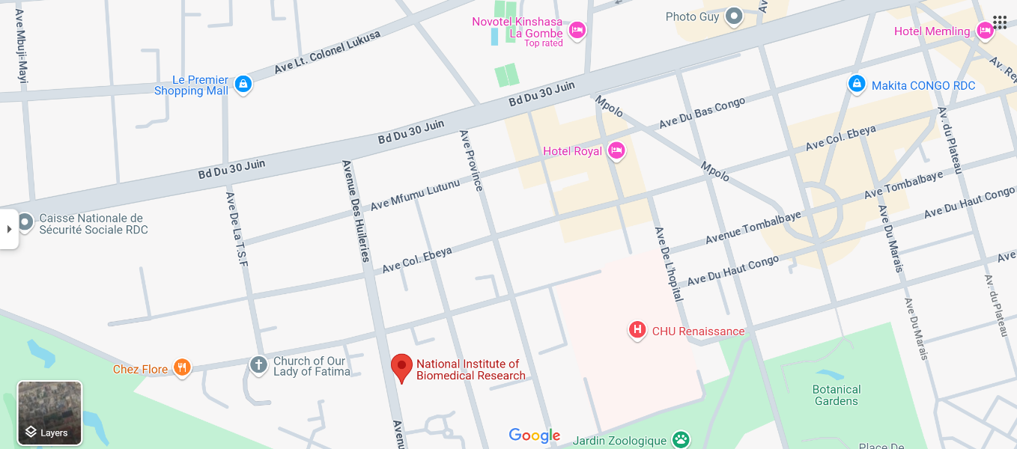
Avenue de la Démocratie (formerly Avenue des Huileries) - Gombe Suburb, Capital City of Kinshasa

